#### PL/SQL Records

* Objects of type RECORD are called PL/SQL records
* PL/SQL records have uniquely named fields, which can belong to different datatypes
  + Define a RECORD type

TYPE <typename> IS RECORD

(fieldname1 <fieldtype>

:

fieldnameN <fieldtype> ;

(%TYPE and %ROWTYPE can be used to specify <fieldtype>]

**Example 1 of Record Type –**

Declare

TYPE empdetails IS RECORD

(**eno** Emp.Empno%type,

**name** Emp.Ename%type,

**s** Emp.Sal%type);

VE empdetails;

Begin

Select empno,ename,sal Into VE

from Emp

where ename = 'SMITH';

dbms_output.put_line(VE.**eno** || ' - ' || VE.**name** || ' - ' ||VE.**s**);

End;

**Example 2 of Record Type –**

Declare

TYPE si IS RECORD

(p number,

n number,

**r number := 4.5**

);

**/* r variable of si type has been given value. */**

VSI si;

x number;

Begin

VSI.p := 5000;

VSI.n := 6;

x := (VSI.p * VSI.n * VSI.r) / 100;

dbms_output.put_line(x);

End;

**Using a record type in another record type.**

**Design 1 🡪 Declaring redundant attributes again & again (Not recommended)**

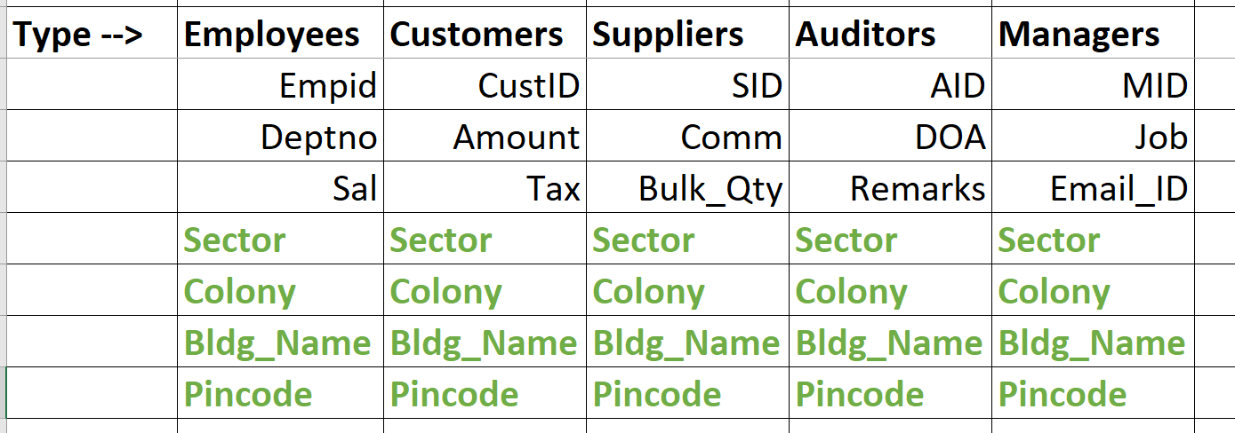

**Design 2 🡪 Declaring redundant attributes in one type. And using that type in another type (Highly recommended!!!!)**

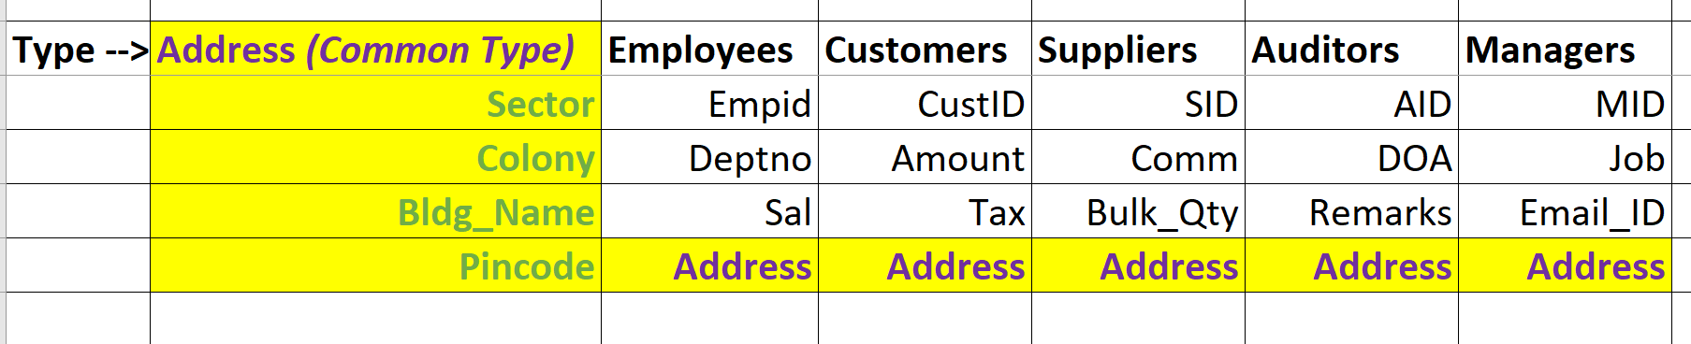

**Declare**

**type Address_details is record**

**(sector char(3),**

**colony varchar2(50),**

**bldg_name varchar2(25),**

**pincode number(7));**

**type personal_details is record**

**(name varchar2(60),**

**Addr** **Address_Details**,

**age number);**

**V personal_details;**

**Begin**

**V.name := 'John';**

**V.Addr.sector := 'S1';**

**V.Addr.colony := 'Model';**

**V.Addr.bldg_name := 'Hill View';**

**V.Addr.pincode := 6775;**

**dbms_output.put_line('The building name is ' || V.Addr.bldg_name);**

**dbms_output.put_line('The pincode is ' ||V.Addr.pincode);**

**End;**

**%Rowtype with Record**

**declare**

**type T1 is record**

**(ed emp%rowtype,**

**dd dept%rowtype);**

**V T1;**

**Begin**

**select * into V.ed**

**from emp**

**where ename = 'KING';**

**select * into V.dd**

**from dept**

**where dname = 'ACCOUNTING';**

**dbms_output.put_line(V.ed.ename);**

**dbms_output.put_line(V.dd.dname);**

**end;**

**/**

**The above program can be illustrated as follows:**

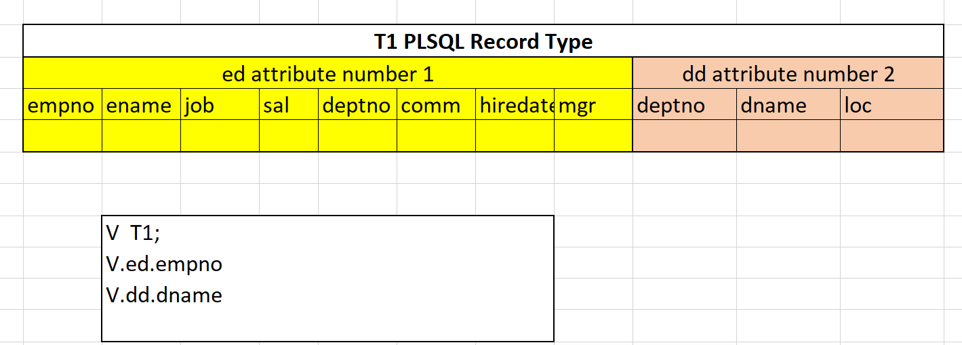

**Customer_Master has 20 columns**

**Customer_EMI_Details has 8 columns**

**Type Customers is Record**

**(cm Customer_Master%RowType,**

**emi Customer_EMI_Details%RowType**

**)**

**C Customers;**

**Assigning Values of one record to another.**

declare

type t1 is record (eno Emp.Empno%type,

name Emp.Ename%type,

s Emp.Sal%type);

v1 t1;

v2 t1;

begin

v1.eno := 3;

v1.name := 'ds';

v1.s := 998;

**v2 := v1;**

dbms_output.put_line (v2.name);

end;